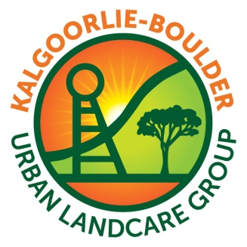
Kalgoorlie-Boulder Urban
Landcare Group
Annual General Meeting

Thursday 3rd October 2013 – 6.00pm
Lotteries House – 42 Wilson St, Kalgoorlie
Nominations and Elections for the Management Committee 2013-2014

Written nominations should be forwarded to:

THE KBULG CEO
KALGOORLIE-BOULDER URBAN LANDCARE GROUP
PO BOX 10381
KALGOORLIE WA 6430
Email: admin@kbulg.org.au

- KBULG is once again seeking an active, engaged and involved Committee to take the organisation forward in the coming year. In agreeing to nominate for election, Committee members undertake not to act in their own self-interest but are voted in to progress KBULG’s mission and objectives.
- All Nominees will be members of KBULG.
- All positions will be declared vacant at the AGM.
- Written nominations must be received 7 days prior by 5pm on 24/09/2013.
- If there are an insufficient number of candidates nominated, nominations may be taken from the floor at the AGM.

For more information call KBULG on 0418 935 498
………………………………………………………………………………………………………...

KBULG AGM – 3rd October 2013

I wish to nominate
for the position of
on the 2013/14 KBULG management committee for the position of.
Chairperson Vice Chairperson Secretary Treasurer Committee Member

Signed: Date: / /

I hereby agree to stand for the above position on the KBULG committee.

Signed by Candidate

Signed: Date: / /

